**POWER BI PROJECT 2- DETAILED DOCUMENTATION**

**AIM-**

To analyse the data of supply and demands in detail of supermarket sales of Yangon, Naypyitaw and Mandalay in the year 2019.

**INTRODUCTION-**

Analysing supermarket sales entails delving into vast datasets to uncover patterns, trends, and insights that drive business decisions. It involves examining transactional data, inventory records, and external factors to understand customer behaviour, product performance, and market dynamics. Through techniques such as segmentation analysis, product performance assessment, and time series analysis, supermarkets gain actionable insights into customer preferences, demand fluctuations, and seasonal variations. Predictive modelling further enables forecasting future sales trends, aiding in inventory management and strategic planning. Competitive analysis and visualization techniques complement these efforts, providing a comprehensive view of market positioning and performance metrics. Ultimately, the analysis of supermarket sales serves as a cornerstone for optimizing operations, enhancing customer satisfaction, and maximizing revenue.

**PROBLEM STATEMENT-**

* What is the no. of counts of products of various categories purchased by each gender?
* How many of them belong to which of the three cities and mode of payment they preferred for purchasing for each product gender wise?
* What are the ratings for each product line?
* What are the number of quantities purchased in the year 2019 for each product line?

**METHODOLOGY-**

* Clearly outline the goals of the visualization analysis. Determine what specific aspects of supermarket sales you want to explore or understand better, such as product performance or customer segmentation.
* Gather relevant sales data from various sources, including transaction records, inventory databases, and customer demographics. Clean and preprocess the data to ensure accuracy and consistency, handling missing values, outliers, and formatting issues as needed.
* Choose appropriate visualization techniques based on the nature of the data and the insights you want to convey. Common visualization types for supermarket sales analysis include:
* Bar charts and line graphs for showing sum of quantities taken or ratings and comparing performance across products or categories.
* Pie charts for illustrating the distribution of sales by product category or customer segment.
* Use visualization tools and techniques to explore the sales data and identify patterns, trends, and outliers.
* Design interactive dashboards that allow users to interact with the data dynamically, filtering and drilling down into specific segments of interest. Incorporate interactive elements such as dropdown menus, sliders, and tooltips to enhance usability and engagement.
* Provide contextual information and annotations to help viewers interpret the visualizations accurately. Include titles, axis labels and legends.
* Continuously refine and iterate on the visualizations based on feedback from stakeholders and insights gained from the analysis. Experiment with different visualization techniques and layouts to find the most effective ways to communicate the findings.

**ANALYSIS-**

* First, we created a slicer of gender to distinguish the information gender wise and then we created a graph by transforming data first and counting number of females and males in each product line. In the graph according to gender than we can see the number of items purchased by that gender in different categories. In this picture we can see we have selected female from the slicer and then number of items of different categories purchased by females can be seen in the graph.

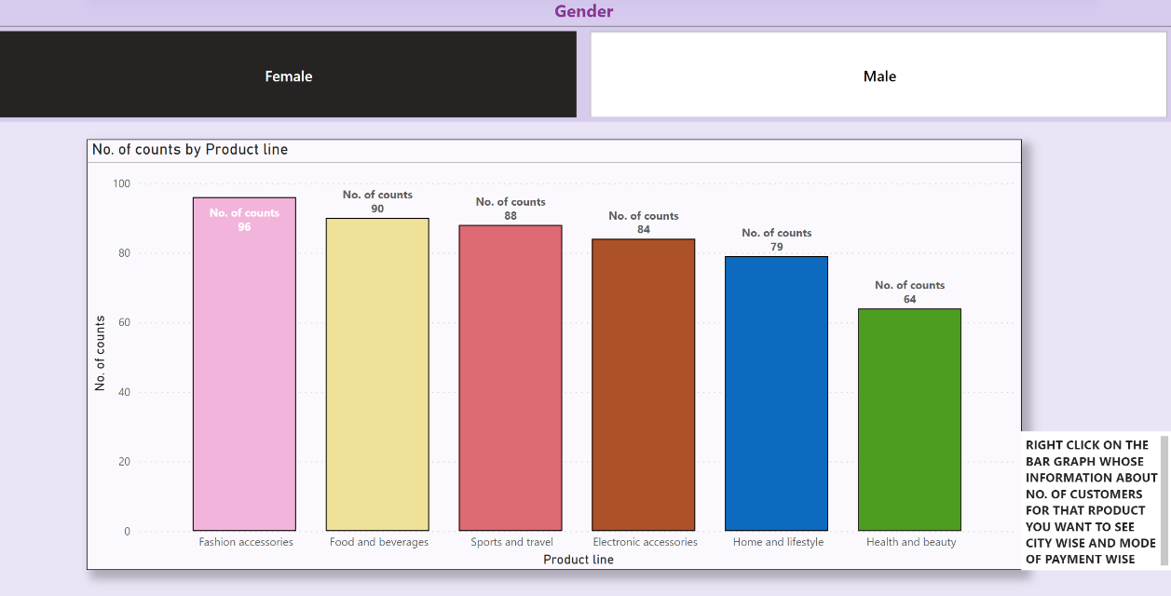

* Then we created another page in which we mentioned no. of customers by city and by mode of payment.
* I created a drill through to that is according to product line selected from the previous graph we can see the males or females(as per selection) in which city did they belong and modes of payment they used.
* In this page I also created a button to navigate to next page in which demand analysis has been done. In this picture I selected foods and beverages product purchased by female which drill us through the analysis of females’ city wise and modes of payment they used.

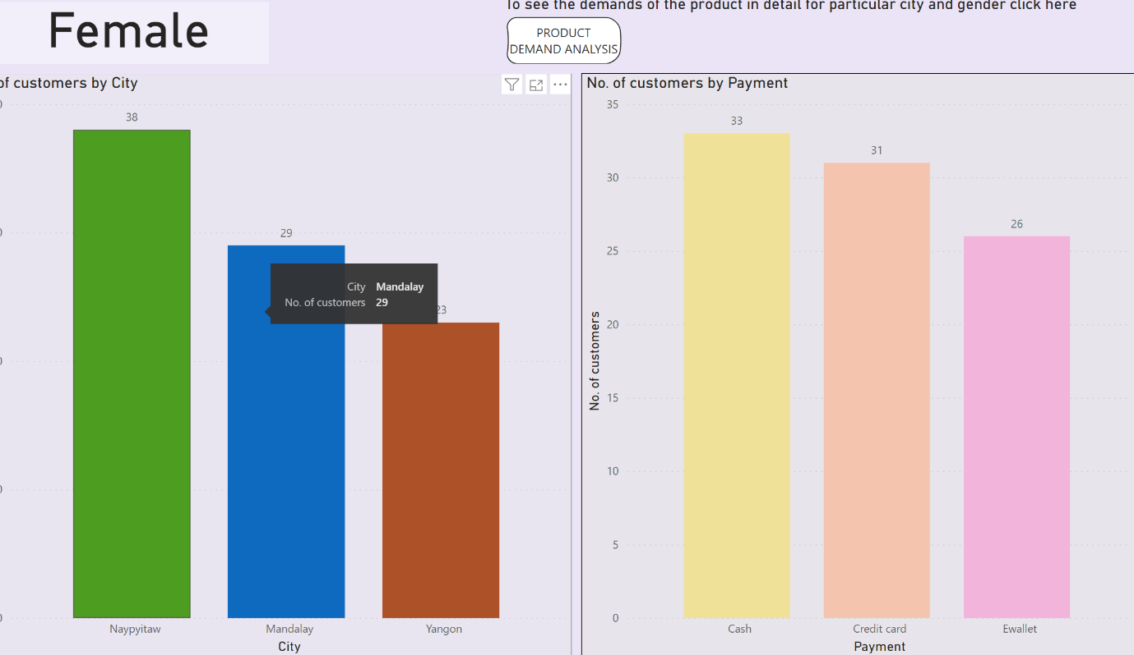

* In the third page, I created 4 visualisations. First one was a table visual in which each product line with its sum of quantity purchased and overall ratings by them is mentioned.
* In the second one a line cum bar chart in which quantity and its ratings can be analysed according to information in the table
* In the third visual I created a gauge chart in which total sales by each product has been mentioned and in fourth one through measures I created a face card in which name of product with maximum demand will be mentioned.
* Then I created 2 slicers one for gender and other for city so that we could see all this information gender and city wise and accordingly the demand analysis can be done. In this picture I selected Male of Mandalay city so we could see first number of quantities and their overall ratings of each product, second the sales that has been done for each product and in Mandalay males highest demand product is in health and beauty category.

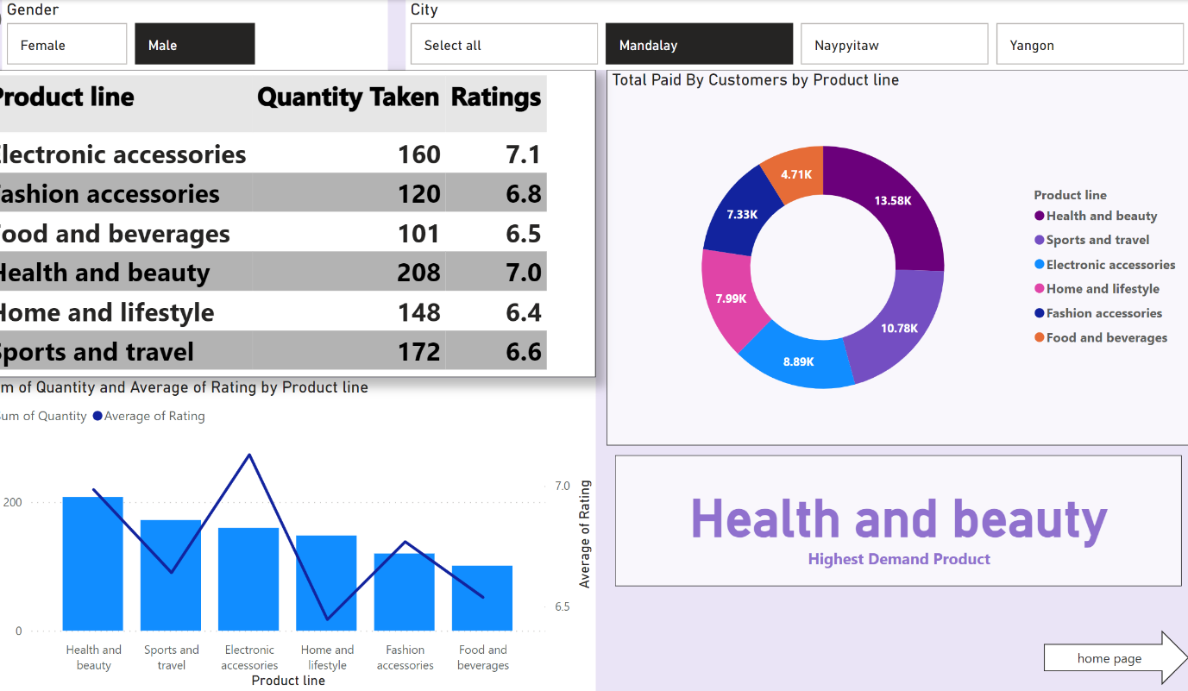

**INSIGHTS-**

* Visualizations can help identify top-selling products, slow-moving items, and trends in product demand. Insights into product performance can inform decisions regarding inventory management, pricing strategies, and product promotions.
* Visualizations can segment customers based on demographics, purchase behavior, or geographic location. Understanding customer segments allows for targeted marketing strategies, personalized promotions, and tailored product offerings to different customer groups.
* Visualizations can uncover associations between products frequently purchased together, enabling supermarkets to optimize product placement, cross-selling strategies, and promotional offers. Identifying complementary products can also help enhance the shopping experience and increase basket size.
* Analysing the impact of promotions and marketing campaigns through visualizations can provide insights into their effectiveness in driving sales and attracting customers. This information can guide future promotional strategies and allocation of marketing resources.
* Visualizing market share and performance metrics relative to competitors can provide insights into market positioning and competitive dynamics. Benchmarking supermarket performance against competitors allows for identifying areas for improvement and differentiation strategies.
* Visualizations of customer feedback and loyalty program data can highlight areas of strength and areas needing improvement in customer satisfaction and loyalty. Insights from customer sentiment analysis can inform strategies for enhancing the customer experience and building brand loyalty.

**RECOMMENDATIONS**-

* Develop interactive dashboards that allow stakeholders to explore the data dynamically. Incorporate filters, slicers, and drill-down capabilities to enable users to focus on specific segments or time periods of interest.
* Include titles, axis labels, legends, and annotations to provide context and clarify the meaning of the data. Explain any trends, patterns, or anomalies observed in the visualizations to help users interpret the findings accurately.
* Keep visualizations clean and uncluttered to enhance readability and comprehension. Avoid unnecessary decorations and distractions, and use color, size, and spacing judiciously to emphasize important information.
* Structure the analysis in a narrative format that guides users through the key insights and conclusions. Use storytelling techniques to frame the analysis in a compelling and coherent manner, focusing on actionable recommendation.
* Continuously refine and iterate on the visualizations based on feedback from stakeholders and insights gained from the analysis. Experiment with different visualization techniques and layouts to find the most effective ways to communicate the findings.
* Foster collaboration and knowledge sharing by enabling users to annotate visualizations, share insights with colleagues, and collaborate on analysis in real-time. Implement features such as commenting, sharing, and exporting to facilitate collaboration.

**CONCLUSIONS-**

In conclusion, the analysis of supermarket sales visualization has unveiled several crucial insights pivotal for strategic decision-making. Through meticulous examination of sales trends, product performance, and customer segmentation, we have discerned patterns and opportunities essential for enhancing operational efficiency and driving revenue growth. The visualization analysis has illuminated the top-selling products and elucidated the effectiveness of promotional campaigns. Moreover, by delving into customer segmentation, we have uncovered valuable insights into consumer preferences and behaviours, paving the way for targeted marketing strategies and personalized promotions. Additionally, competitive benchmarking has provided perspective on market positioning and highlighted avenues for differentiation. Armed with these insights, the supermarket can now formulate actionable recommendations to optimize inventory management, refine marketing strategies, and elevate the overall customer experience. Ultimately, the analysis of supermarket sales visualization serves as a cornerstone for informed decision-making, enabling the supermarket to stay agile, competitive, and responsive to evolving market dynamics.